**#Backup and restoration**   
  
Let’s first launch an EC2 instance within console.

and connect EC2 instance via ssh.  
Once connected via ssh, will try to create a file on same.  
  
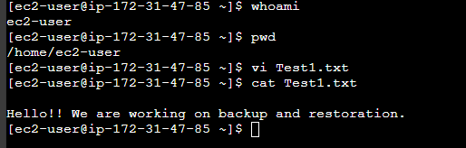

Here, we have created Test1.txt file with some content.

Now, we will create an image of the ec2 instance.

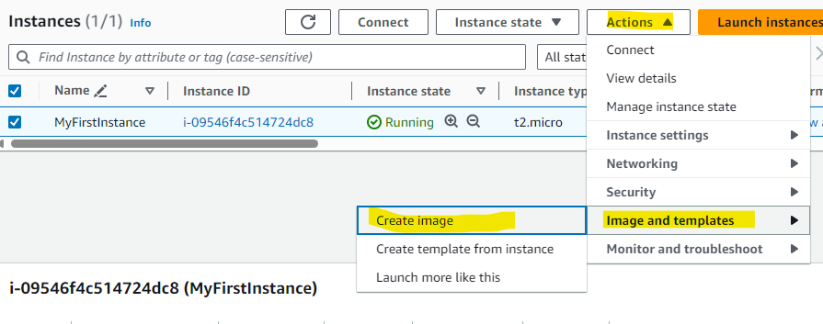

and launch it as a new instance.  
  
Once Instance is launched, we will have once more instance added  
  
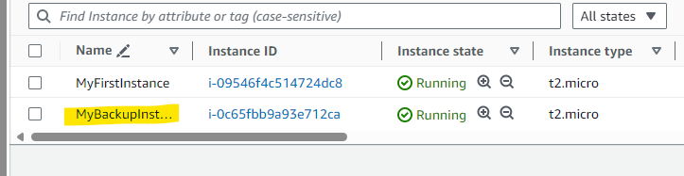

And finally, we can verify if it has replicated files as same as in first instance.  
  
